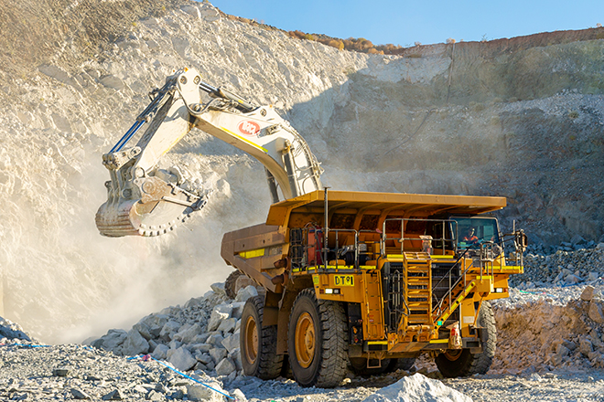

**Market Snapshot**

The report emphasizes the growing significance of lithium mining equipment in supporting the global clean energy transition. Driven by surging EV demand, renewable energy storage, and sustainable mining initiatives, the industry is witnessing rapid innovation and global expansion.

**Key Drivers:**

* Increasing EV and energy storage demand.
* Advancements in direct lithium extraction (DLE).
* Expanding renewable energy investments.
* Government incentives for clean mining operations.
* Rising adoption of automation and smart mining systems.

**Market Segmentation Overview**

The market is segmented into four key categories: **Type of Lithium Deposits, Type of Lithium Compounds Produced, Extraction Process, and End-Use Industry**. Each plays a crucial role in defining lithium supply chain efficiency, sustainability, and global competitiveness.

**By Type of Lithium Deposits**

* **Hard Rock (Spodumene):** Established source with high lithium yield through conventional mining.
* **Brine Deposits:** Economical extraction from salt flats using solar evaporation.
* **Lithium-Containing Clays:** Promising new source under development.
* **Others:** Unconventional sources under pilot studies.

**By Type of Lithium Compounds Produced**

* **Lithium Carbonate:** Key compound for batteries and glass manufacturing.
* **Lithium Hydroxide:** Preferred by EV battery makers for enhanced performance.
* **Lithium Chloride:** Used in chemical processing and industrial cooling.
* **Others:** Specialized compounds for niche applications.

**By Extraction Process**

* **Traditional Mining (Hard Rock):** Conventional but energy-intensive method.
* **Solution Mining (Brine Deposits):** Low-cost method dependent on climate.
* **Direct Lithium Extraction (DLE):** Innovative and sustainable extraction process.
* **Others:** Hybrid extraction technologies being tested globally.

**By End-Use Industry**

* **Batteries (EVs, Consumer Electronics):** Largest demand contributor.
* **Glass & Ceramics:** Improves product quality and strength.
* **Lubricating Greases:** Enhances performance in high-friction applications.
* **Pharmaceuticals:** Used in medicine manufacturing.
* **Others:** Industrial and chemical processing uses.

**Key Players**

The market features competitive dynamics with companies focusing on sustainable growth and vertical integration.

* **Albemarle Corporation:** Expanding lithium operations and R&D investments.
* **SQM:** Strengthening brine-based extraction capacity in Latin America.
* **Tianqi Lithium Corporation:** Partnering for downstream lithium processing.
* **Ganfeng Lithium Co. Ltd.:** Investing in recycling and circular economy solutions.
* **Livent Corporation:** Focused on high-purity lithium for next-gen batteries.

Companies are investing in green mining technologies, strategic alliances, and global supply diversification.

**Regional Dynamics**

* **North America:** Increasing lithium exploration and investment in battery supply chains.
* **Europe:** Building local lithium refining and EV battery ecosystems.
* **Asia-Pacific:** Largest market due to abundant resources and manufacturing hubs.
* **Latin America:** Leading brine-based lithium production region.
* **Middle East & Africa:** Emerging with early-stage lithium exploration and partnerships.

**Market Opportunities and Challenges**

**Opportunities**

* Rapid expansion of EV production worldwide.
* Rising investments in sustainable lithium extraction.
* Growing integration of AI and IoT in mining operations.
* Increase in recycling and recovery technologies.
* Government support for local lithium production.

**Challenges**

* Environmental and water-related concerns in brine mining.
* Volatile lithium pricing due to demand-supply gaps.
* Technical limitations in DLE scalability.
* Regulatory delays and permitting restrictions.
* Dependence on specific geographies for lithium sources.

**Future Outlook**

The lithium mining equipment market is poised for robust growth driven by global electrification and renewable energy trends. Innovations in DLE, automation, and green extraction will redefine production efficiency. Strategic mergers, recycling initiatives, and localization of supply chains will be key to achieving long-term sustainability and competitiveness across regions.

**Informational Sources:** <https://valuemarketresearch.com/report/lithium-mining-equipment-market>